Preliminary Analysis
There are 684754 entries of data dated from 01/01/2012 to 07/04/2015.

For each observation, the information includes:

Date Of Stop | Time Of Stop | Agency | Sub-Agency | Description | Location
Latitude | Longitude | Accident | Belts | Personal Injury | Property Damage
Fatal | Commercial License | HAZMAT | Commercial Vehicle | Alcohol | Work Zone
State | Vehicle Type | Year | Make | Model | Colour
Violation | Type | Charge | Article | Contributed To Accident | Race
Gender | Driver City | Driver State | DL State | Arrest Type | Geolocation

The core features of the observations for the analysis are determined as:

- Location (Latitude, Longitude)
- Gender
- Vehicle information (Makes, Car Type, Model)
- Violation information (Type of Violation, Time and Date)

The distribution of the core features are stated below:

Fig. 1 shows us the locations where those accidents usually happened.

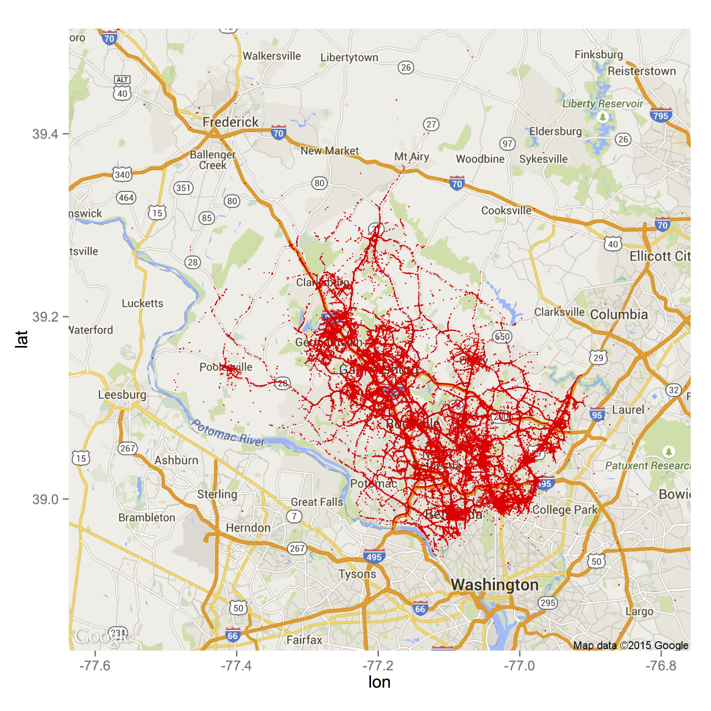

Fig 1. Point Distribution of Locations

Fig. 2 gives us the overview of the gender that violated the traffic rules.

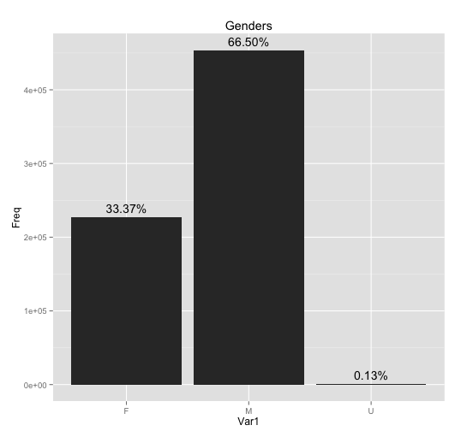

Fig 2. Gender Distribution

Legend
- Var 1- Variable 1
- F- Female
- M- Male
- U- Unknown

Fig. 3 shows us the top 5 manufactures of the car that violated the traffic rules.

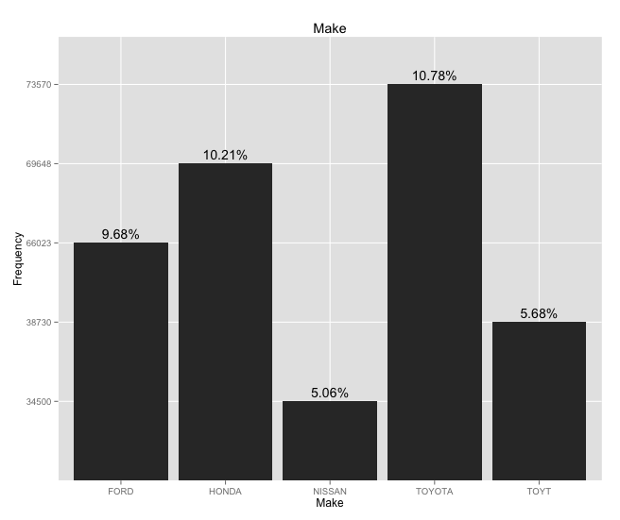

Fig 3. Car Manufacturer Distribution (Top 5)

Fig.4 shows us the top 5 car models that violated the traffic rules.

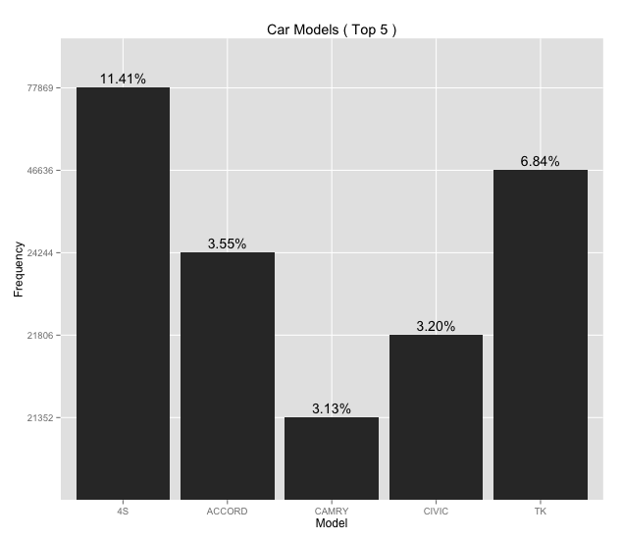

Fig 4. Car Model Distribution (Top 5)

Fig.5 shows us the top 5 types of vehicle that violated the traffic rules.

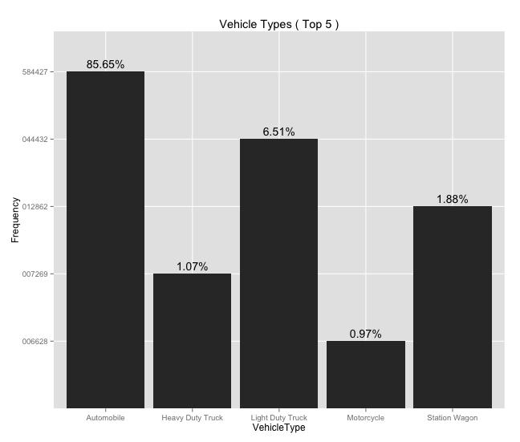

Fig 5. Vehicle Types Distribution (Top 5)

Fig.6 shows us the top 5 types of traffic violation happened in the country.

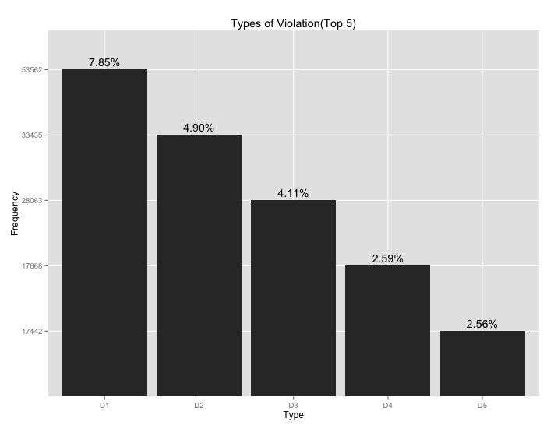

Fig 6. Violation Type Distribution (Top 5)

Legend

- Driver failure to obey properly placed traffic control device instructions
- Failure to display registration card upon demand by police officer
- Driving vehicle on highway with suspended registration
- Operator not restrained by seatbelt
- Failure of individual driving on highway to display license to uninformed police on demand

Analysis from the graphs above

- Most of them who violated the traffic regulation are male.
- Most of the cars involved in traffic violation are manufactured by Toyota.
- Most of the cars involved in traffic violation are automobile.
- Most of the cars involved in traffic violation are of model 4S.
- The main reason for traffic violation is because driver failed to obey the properly placed traffic control device instructions.

For the vehicle type distribution, the differences are statistically significant as 85% of these cars are automobile.

Other salient aspects of the data

- The dataset includes information on latitude and longitude of the locations of traffic violations.
- For instance, the locations and the description are found in text form.

Next 5-10 tasks

- Plot a heat map showing date distribution of traffic violations
- Discover more correlations between the places of traffic violations and the actual road map
- Plot various information by month to discover seasonal changes of the characteristics of traffic violations
- Discover more correlations and difference between gender by separating the data by gender
- Find out more the effect of alcohol on male and female
- Discover how the presence of absence of seat belts affects fatality

